# Getting Started with Visual Studio, Apache Cordova and jQuery Mobile

## Create an Apache Cordova Project

1. Open Visual Studio **2017** and create a new project by opening the File menu, select New then Project
2. In the **New Project** dialog, open the list of installed templates, and expand the **JavaScript** option. In the list of templates that appears there, select **Blank App (Apache Cordova)** as shown in the figure:

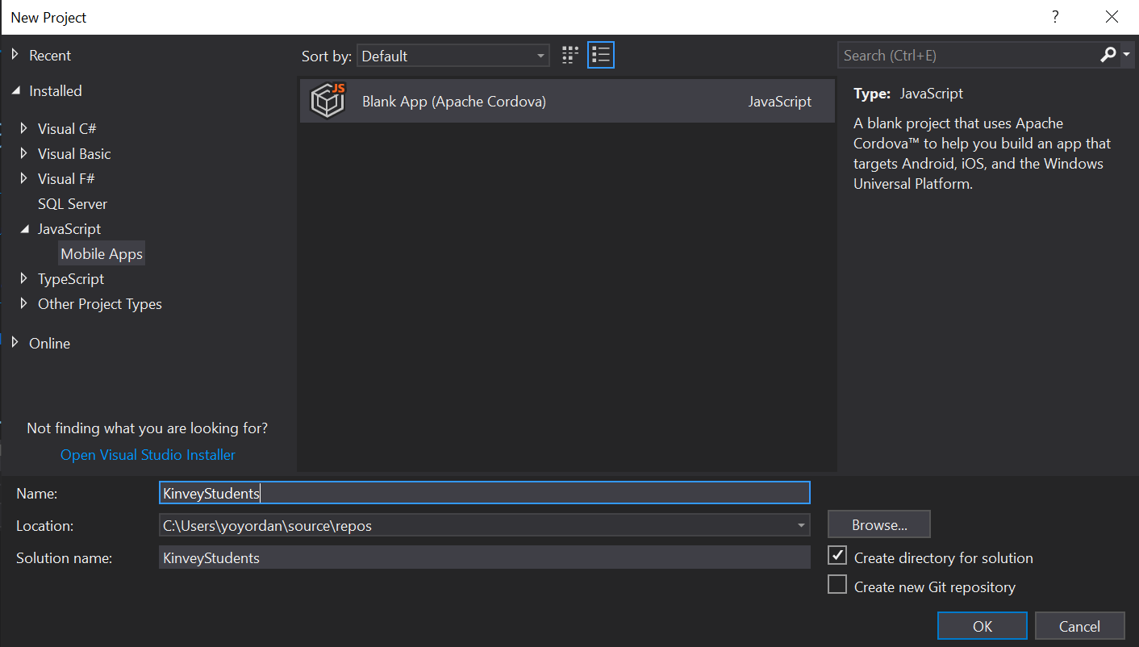

1. Name the project **KinveyStudents**, specify a target folder, and then click the **OK** button to create the project.
2. In Visual Studio, open **Tools** -> **NuGet Package Manager** -> **Manage NuGet Packages for Solution**, and add the **jQuery.Mobile** NuGet package to your solution.
3. When you click the **Install** button, the NuGet Package Manager will display a confirmation dialog highlighting the components being installed. Notice that it's installing jQuery version 1.8 rather than the latest version for compatibility reasons.
4. NuGet adds files to the Visual Studio project's Scripts folder, but they really belong in the Cordova project's www/scripts folder. Drag all of the **.js** files from the Scripts folder to the www/scripts folder as shown in the figure.

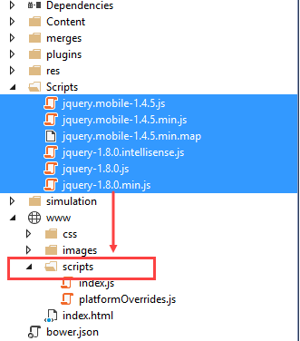

1. NuGet also installs the frameworks' CSS files to the Visual Studio project's Content folder, but they really belong in the Cordova project's www\css folder. Drag the **images** folder plus all of the **.css** files from the project's Content folder to the www\css folder 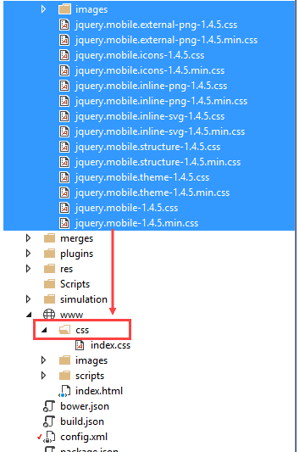
2. Add this script reference to the <body> tag of your project's [index.html](https://docs.microsoft.com/en-us/visualstudio/cross-platform/tools-for-cordova/first-steps/build-your-first-app?view=toolsforcordova-2017#tour-project) file. Place the content at the bottom of the body section, where the other JavaScript references are located:

<script src="scripts/jquery-1.8.0.min.js"></script>

<script src="scripts/jquery.mobile-1.4.5.min.js"></script>

1. Add the following style reference to the <head> tag of your project's [index.html](https://docs.microsoft.com/en-us/visualstudio/cross-platform/tools-for-cordova/first-steps/build-your-first-app?view=toolsforcordova-2017#tour-project) file. Place the content above the existing index.css reference:

<link rel="stylesheet" href="css/jquery.mobile-1.4.5.min.css" />

1. Save your changes to the project's index.html

## NOW THE REAL DEAL!!!

Your task is to create functionality for creating and listing students from a database in Kinvey.

Here are the Kinvey application key and secret:

* APP KEY: kid_BJXTsSi-e
* APP SECRET: 447b8e7046f048039d95610c1b039390

Here is also a test user for you to log in with:

* Username: guest
* Password: guest

There is collection called students there, in the application.

The student entity has:

* ID – a number, **non-empty**
* FirstName – a String, **non-empty**
* LastName – a String, **non-empty**
* FacultyNumber – a String of **numbers**, **non-empty**
* Grade – a number, **non-empty**

You need to write functionality for creating students. When you are creating a new student, make sure you name these properties perfectly. Create at least one student to test your code.

### Screenshots

